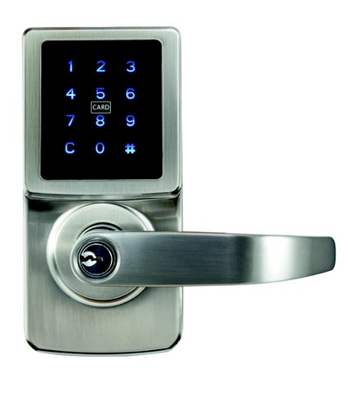

Carbine CEL 3in1 Touchscreen Locks
RFID Application List

Credit Cards & Transport Cards
Any RFID cards that are using MIFARE chips will be compatible with the lock. The MIFARE chips (ISO14443 Type A) are widely used on transport cards, but not credit cards as most credit cards including VISA PayWave & Mastercard Paypass use EMV chips (ISO14443 Type B) which are not compatible with the lock.
However, if the credit card can also be used as a transport card (complying to ISO14443 Type A), it is very likely it can be used to operate the lock.
The table below lists the transport cards that are equipped with MIFARE chips in Australia. The link below has more information about MIFARE.
https://en.wikipedia.org/wiki/MIFARE
Card Name | Locality | Type | Details
Adelaide Metro metroCard | Australia (Adelaide) | MIFARE DESFire EV1 | Adelaide Metro network (Bus, Train and Tram)
TransLink Go card | Australia (Brisbane) | MIFARE Classic 1K | Used on the TransLink public transport network.
ACTION MyWay | Australia (Canberra) | MIFARE Classic 1K | Form of electronic ticketing used on public transport services within Canberra
Metro Green Card | Australia (Hobart) | MIFARE Classic 4 | Greencard simplifies public transport by acting like a digital wallet. Used on buses and the metro.
SmartRider | Australia (Perth) | MIFARE Classic 1K | Widely used across the Transperth public transport in metropolitan Perth, as well as the regional town bus services. Used for public bus, train and ferry services.
Opal card | Australia (Sydney) | MIFARE DESFire EV1 | Is valid on all bus, rail, light rail and government ferry services in Sydney and surrounding areas such as Central Coast.
Myki | Australia (Victoria) | MIFARE DESFire | Used on public transport such as, trains, buses, trams and coaches in Victoria

SmartPhones
In addition, most Android phones with NFC function can also be used to operate the lock. Refer to the link below to see which smartphone brands and model numbers are using the MIFARE technology
http://www.shopnfc.it/en/content/7-nfc-device-compatibility

RFID Cards / Fobs from other manufacturers
In order to guarantee compatibility with the locks, it is recommended to only use the original Carbine RFID cards
Some other manufacturers RFID cards / fobs with MIFARE chips will be able to be added to the lock and operate it
However if any changes are made to the settings of those cards /fobs in the original reader they are used in, this may affect operation with the Carbine lock

Technical Support
Davcor is only able to provide support for our Carbine locks and original cards
Any issues arising from using other manufacturers hardware to operate our locks may not be able to be resolved due to the settings in the other hardware

